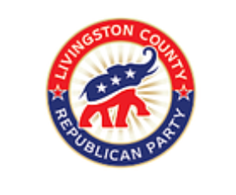
COUNTY CONVENTION AGENDA
Thursday, August 15, 2024

- Call to Order by Temporary Convention Chair
- Invocation
- Pledge of Allegiance
- Appointment of Temporary Secretary and reading of Official Convention Rules
- Temporary Secretary reads Call to Convention
- Temporary Chair appoints Temporary Parliamentarian and Seargent-at-Arms
- Waiver of formal reading of Delegates
- Election of Permanent Chair
- Permanent Chair appoints Permanent Parliamentarian, Sgt-at-Arms, and Tellers
- Nominations and Election of Permanent Secretary
- Oath of Office is administered to all Permanent Convention offices
“I do solemnly swear that I will support the Constitution of the United States and that I will faithfully discharge the duties of the office of ______ according to the best of my ability, so help me God.”
- Permanent Chair appoints Credentials Committee Chair and Rules Committee Chair
- Credentials Committee Chair report
- Rules Committee Chair report
- Hardworking Republican Rule
- Election of Delegates to the August 24, 2024 State Convention, Round 1 voting
- Results and announcement of Delegates selected; tie for #61 handled by a draw of numbers
- Election of Alternates to the August 24, 2024 State Convention, Round 2 voting
- Remarks from Candidates
- Results and announcement of Alternates 1-61; any ties handled by a draw of numbers
- Appointment of Precinct Delegate vacancies
- Permanent Chair asks for further County Convention business.
- Announcements
- Adjournment

